Report on Community Notice Boards

in Kings Ash and Collaton St Mary

Kings Ash
Boards Already Present

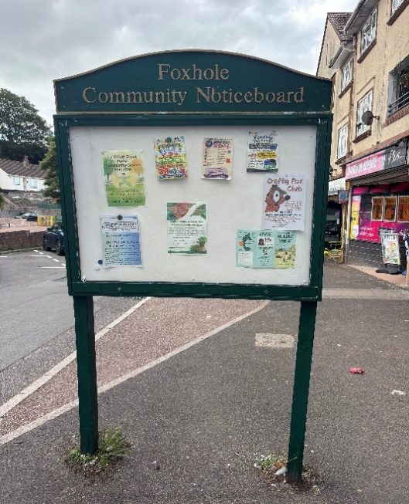
Foxhole Shops has a large double sided notice board. It has recently been refurbed and is in good working order.

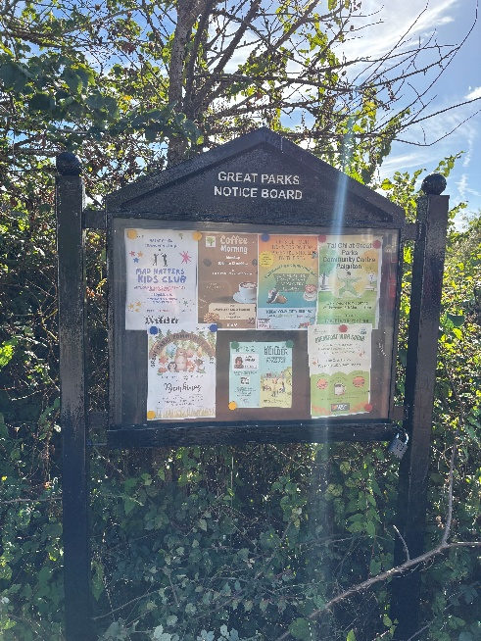
This is the Notice Board in Lutyens Drive in the Great Parks Area. This has also been recently refurbished

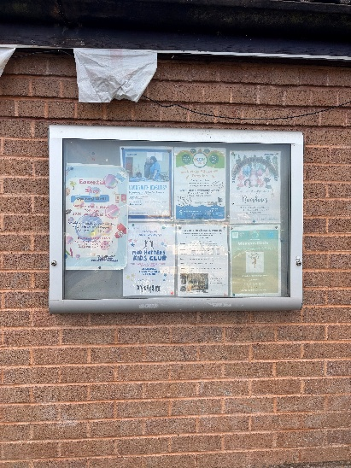
Great Parks Community Centre has one on the side of the building.

These are the only notice boards currently in Kings Ash. Foxhole Community Centre does have one but it’s inside the building.

Areas for possible boards in Kings Ash

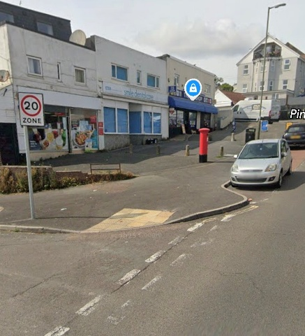
The shops in Marldon Road, known locally as the Top Shops in Foxhole has no Community Notice Board.

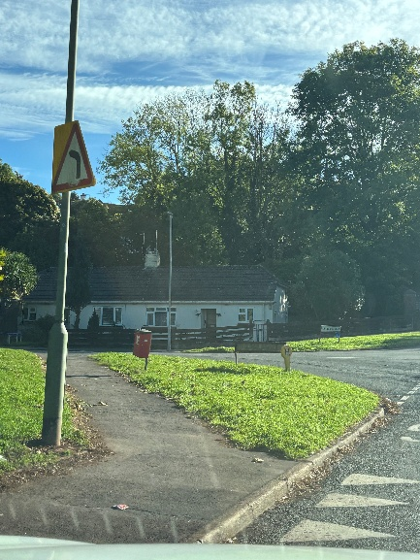
This is an area at the bottom of Underidge Road, which is at the entrance to Foxhole and near a bus stop where many people congregate and walk past.

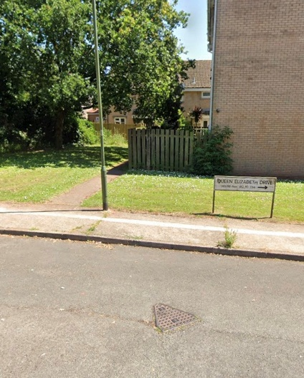
Area at the opposite end of QED from the Community Centre at Great Parks. IT’s an area where many dog walkers pass and people walking into town.

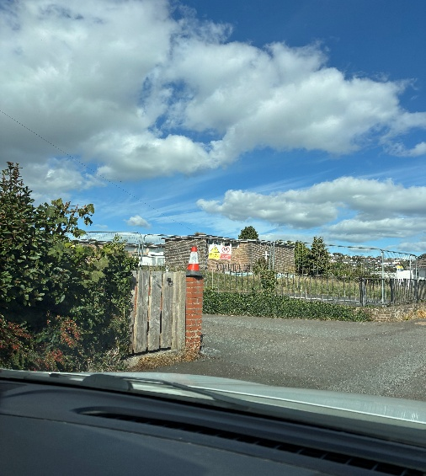
This is the entrance to Foxhole Community Centre which would be a good place for a Community Board. The construction of the Flats is soon to commence here. When complete this would be a good place, as many people walk past here going to the Community Centre, to school and also for new residents in the flats

These are just some suggestions but is not exhaustive.

Collaton St Mary
Boards Already Present

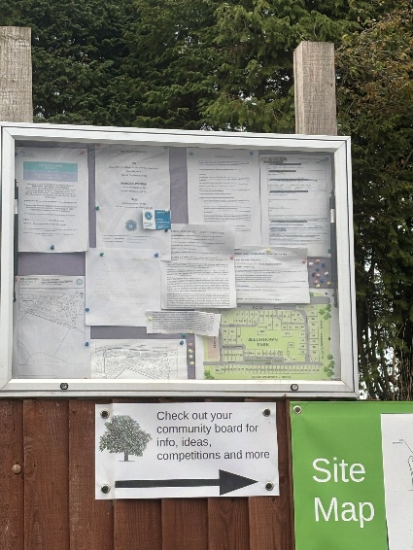
This board is at Beechdown Residential Park on the Totnes Road. UPDATE 26.10.26 – This notice board is owned by Wyldecrest and cannot be used for any other purpose.

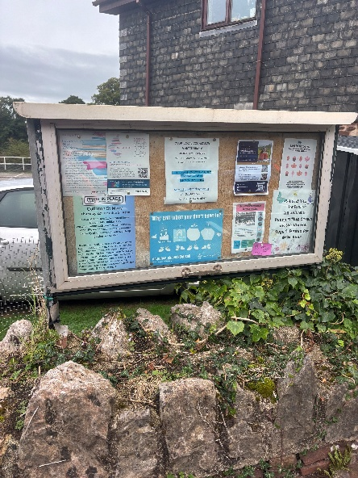
This notice board is outside the old BMW garage on the Totnes Road in Collaton St Mary. It is actually made from an old window.

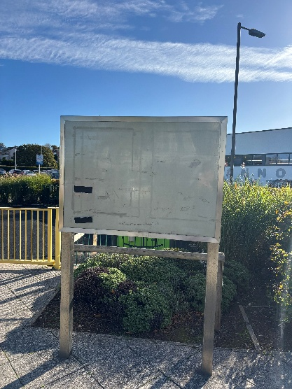
This board is near Aldi. It’s a good size but needs some TLC , cleaning mainly, due to tape being used to stick posters on it. It was empty

Areas for possible Community boards in Collaton St Mary

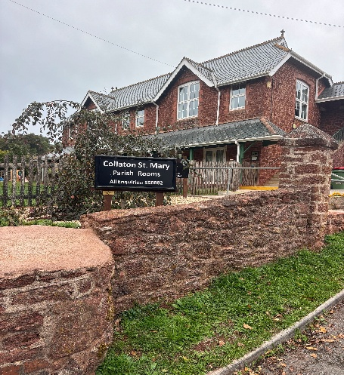
At the Collaton St Mary Parish Rooms there is no community notice board.
UPDATE 26.10.26 – Jacqui Leigh has had a quote for this for a design that would be conducive to the building and area. It would be £800 to make it and £50 to install.

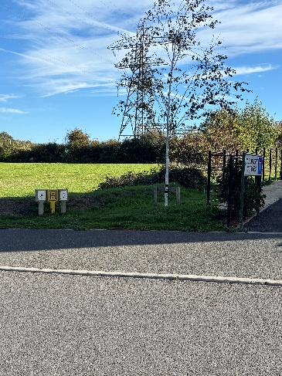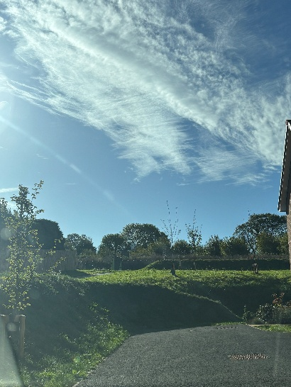
There are two possible areas in the Berry Acres new estate behind Sainsbury’s. This first picture is at the entrance to the estate. The second picture is at the entrance to the play area and circular walk. There are no other Community Notice boards in this area.

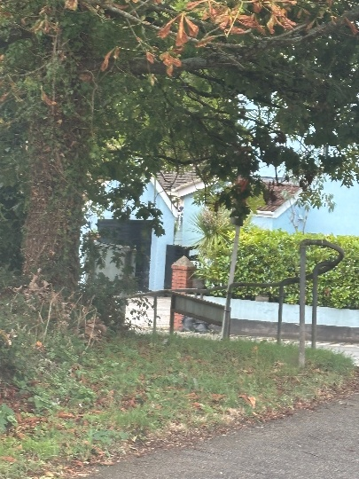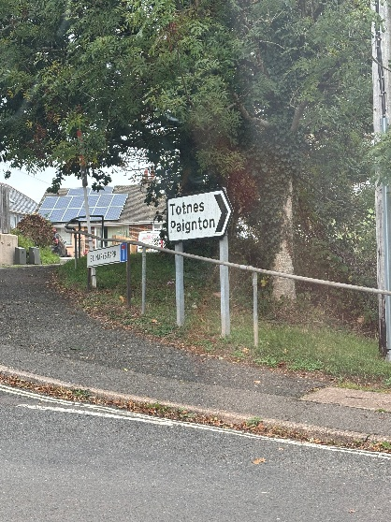
This is a green Space at the entrance to St Mary’s Park area of Collaton St Mary. This is on the Stoke Gabriel Road and is a small community on it’s own. This area is where everyone who walks, will pass and those driving will see it clearly.

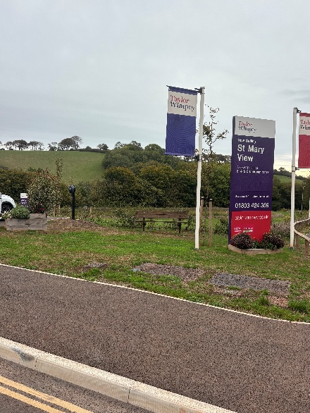
At the entrance to St Mary’s View, the new estate on the road to Totnes. The estate is still being built in areas but there are not community areas or notice boards

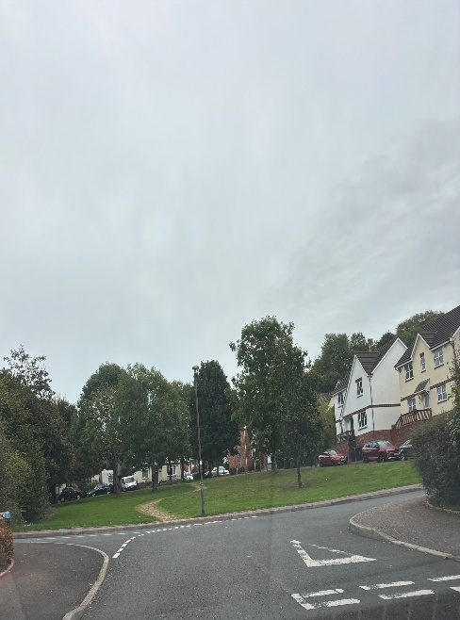
The green space area at the beginning of Pennine Way, where the pop up was held. This area is near Paignton Academy off Borough Road.

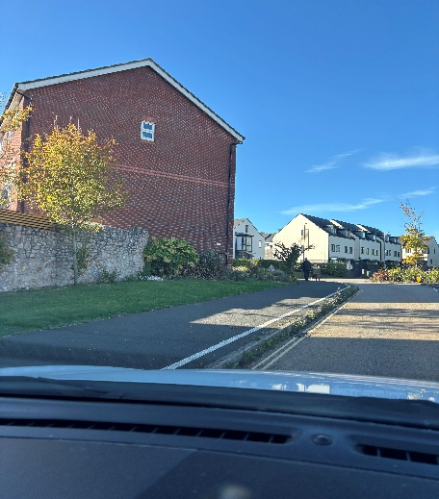
This is the entrance to the white rock estate by Aldi. There is a small green space suitable for a notice board.

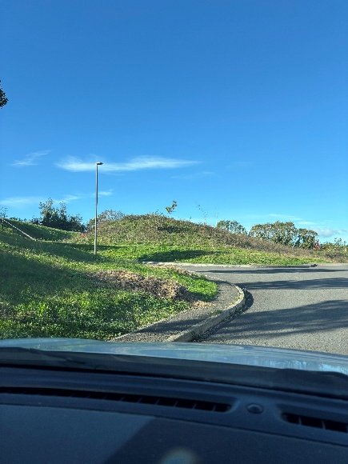
This area is at the top of Hollyhock Way in White Rock. It is popular with families and dog walkers as it is near the play area and also a dog exercising area. It would be well seen.
The above are only suggestions to where new community notice boards could be placed.

